**THE WAVE ACTIVITY IN THE ANAPA BAY BAR AREA: CLIMATIC TRENDS OVER THE PAST 37 YEARS**

***Boris Divinsky, The Southern Branch of the P.P. Shirshov Institute of Oceanology RAS,***

***divin@ocean.ru***

***Ruben Kosyan, The Southern Branch of the P.P. Shirshov Institute of Oceanology RAS, rkosyan@hotmail.com***

**Abstract. The main goal of this research is to study the storm activity in the Anapa bay bar area in the period from 1979 to 2015. We used the method of mathematical modeling. We found that in the region of Anapa bay bar, average annual power of wind waves is 4-5 kW/m and varies significantly during the year. In the wind rose of waves, there are two prevailing direction: north-east and south-west. At the same time, in the inter-annual terms there is a steady increase in the share of waves of northeastern direction with a decrease in the contribution of waves of southwestern direction.**

*Key words: Black Sea, Anapa bay, numerical simulation, wave climate*

I. MAIN TASK

The surface wind waves is one of the main factors that determine the development of maritime transport, offshore development, the dynamic processes in the coastal zone and affecting coastal infrastructure, environmental and recreational potential. In this connection, an important task is to analyze the storm activity in the Black Sea, as well as identifying climate trends in interannual variations of available wave energy.

II. Method of research

A modern mean of surface waves parameters investigation is mathematical modeling, allowing for calculation the parameters of sea waves by initial wind fields for any period of time. To simulate the wave field transformation, advanced spectral model DHI MIKE SW ([3]) is used.

In the model, there are fully implemented stages of birth, damping and transformation of wind wave fields with considering the following physical mechanisms:

* refraction of wave rays in the field of variable bathymetry and currents;
* diffraction (approximately);
* blocking and reflection of waves on the crosscurrent;
* impermeable barriers;
* wave energy dissipation due to bottom friction, caving and turbulence;
* three- and four-wave interaction.

The model can be successfully applied for the open waters and in the coastal zone.

*Construction of the computational grid*

An irregular computational grid, based on bathymetric map the Black and Azov seas (Fig. 1), using a method of triangulation, consisting of 15000 elements (Fig. 2) was constructed (with concentration in the shelf area). Minimal horizontal scale of the grid represents a compromise between requirements of spatial resolution bathymetry features and acceptable computation time.

The position of calculation point is shown in Fig. 3. The depth of the point is 38 meters. In the future, the parameters of wind waves received to this point will be used for modeling the dynamics of the underwater part of Anapa bay bar and coastal edge on climatic time interval.

*The initial wind fields*

As it is known, wind is the main source of energy supply for the waves and one of the major for marine currents. Maps of ground-level atmospheric pressure are selected from an array of data of global atmospheric reanalysis ERA-Interim, represented by the European Centre for medium-term forecasts (http://apps.ecmwf.int).

|  |  |
| --- | --- |
| БАС Бати Легенда.jpgAna.jpgБАС Бати.jpg  *Fig. 1. Bathymetric map of the Black and Azov Seas (м)* | БАС Сетка.jpg  *Fig. 2. Computational grid, covering the Black and Azov Seas* |

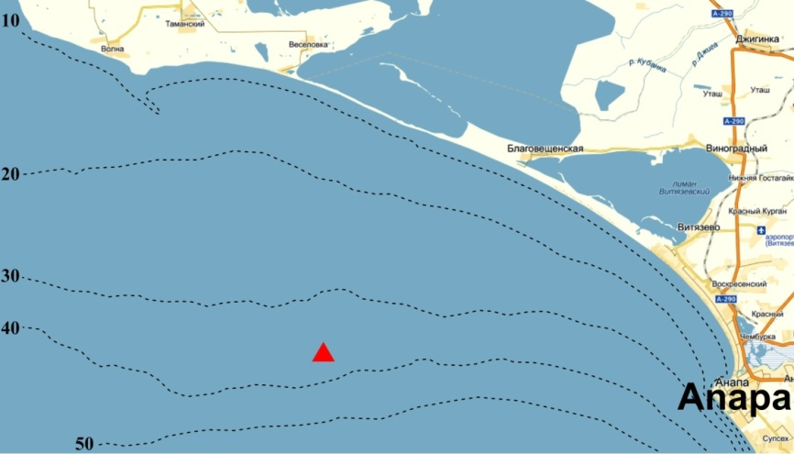

*Fig. 3. The position of calculation point (red triangular) in the area of Anapa bay bar*

Spatial resolution is 0.25 degrees, a step time - 3 h. Gradient wind is determined by arrays of surface pressure and then by correction, the horizontal components of the standard wind at a height of 10 m above sea level (U10, V10) are calculated. It is necessary to note, that the ERA-Interim analysis is presented since 1979 and is freely available. Thus, ERA-Interim data allow to form a field of atmospheric pressure and wind velocity components at a given water area with a time step of 3 hours.

*Verification of the model*

Verification of the spectral wave model has been conducted with the involvement of direct experimental observations. We have to admit that, comparing to other areas of the World ocean, in-situ measurements of parameters of surface waves are not enough in the Black and Azov Seas. However, for this analysis, we have managed to draw the experimental data, which cover almost all the sea and have been carried out with the help of:

1. Wave recorders Datawell Waverider. These data are the most representative, since they include all the basic integral and spectral characteristics of the waves.
2. ADCP. The only record we could find to the Sea of Azov.
3. String wave recorders installed on fixed offshore platforms. Disadvantage - a visual determination of the direction of wave propagation. Besides, wave record analysis provides an estimate of *h*1/3 (medium wave from the third largest), which in itself may be different from the spectral evaluation of a significant wave height *h*s.
4. Satellite measurements (altimetry). The result of the processing of satellite data is a profile of significant wave height along the path of motion of the satellite.

Summary of wave recording devices on the waters of the Black and Azov Seas is shown in Table 1, the position of sensors - in Fig. 4.

*Table 1. The points of observation of the wind waves parameters on the Black and Azov seas basins*

|  |  |  |  |  |  |  |
| --- | --- | --- | --- | --- | --- | --- |
| Number | Device | Station | Coordinates | Depth | Period | Reference |
| **1a** | **Datawell**  **Waverider** | **Gelendzhik** | 44о30’40 N  37o58’70 E | 85 | 01.12.1997-31.03.1998 | [5] |
| **1b** | **Gelendzhik** | 44о30’40 N  37o58’70 E | 85 | 01.12.2002-28.02.2003 |
| **2** | **Sinop** | 42o07'24" N  35o05'12" E | 100 | 01.12.1995-31.03.1996 | [8] |
| **3a** | **Hopa** | 41o25'24" N  41o23'00" E | 100 | 01.12.1995-31.03.1996 |
| **3b** | **Hopa** | 41o25'24" N  41o23'00" E | 100 | 01.12.1997-31.03.1998 |
| **4** | **ADCP** | **Black Sea** | 44o34'11" N  37o58'26" E | 22 | 29.10.2010-05.12.2010 | [13] |
| **5** | **Sea of Azov** | 46o11'56" N  37o06'56" E | 12 | 01.10.2004-30.10.2004 | [9] |
| **6** | **Stationary platform**  **(wave staff)** | **Gloria** | 44o31'00" N  29o34'00" E | 50 | 01.01.2002-30.04.2002 | [12] |
| **7** | **MHI** | 45o42'30" N  31o52'30" E | 30 | 01.10.1998-28.02.1999 | [7] |
| **8a** | **Satellite**  **altimetry** | **AVISO** | 43o00'00" N  31o00'00" E | 1900 | 01.01.2010-31.12.2010 | [1] |
| **8b** | **AVISO** | 43o00'00" N  34o00'00" E | 2200 | 01.01.2010-31.12.2010 |
| **8c** | **AVISO** | 43o00'00" N  37o00'00" E | 2100 | 01.01.2010-31.12.2010 |
| **9** | **ERS-2** | See fig. 4 | Surface track | 25.03.2002 | [10] |
| **10** | **JASON-2** | See fig. 4 | Surface track | 09.12.2012, 19.12.2012 | [4] |

We note a few details:

1. Column "period" in the Table. 1 does not refer to the whole period of operation of the device, but corresponds to the selected time interval, during which verification of wave model has been conducted.
2. Portal of altimetry data AVISO provides averaged over 5 days estimates of significant wave heights. For this reason, the results of calculations when compared with materials of AVISO were also averaged over the same period.
3. In the absence of a unified international program for the experimental study of wind waves of the Black Sea it is quite difficult to obtain synchronous for all the sea recordings of wind waves parameters, for example, for the western and eastern parts simultaneously. Such records would be very useful for verifying the model for different conditions of waves formation. Non-contact methods (satellite altimetry, radar) can not be a quality alternative to the same buoy measurements, since the very satellite data processing algorithms involve the use of contact observations data as reference points. The only exception - carried out in 1994-2000 international Project NATO TU-WAVES ([6]), materials of which are still widely used.

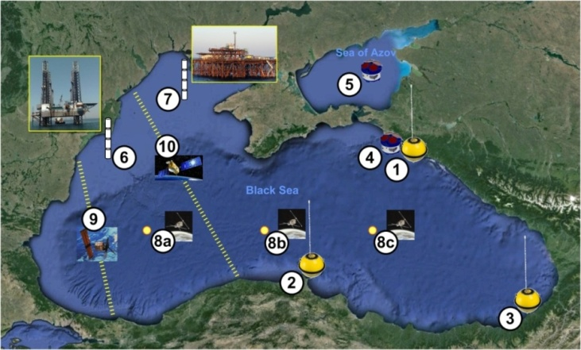

*Fig. 4. Position of wave measuring devices in the Black and Azov Seas*

Thus, setting MIKE 21 SW model has been made using the results of various field studies across the waters of the Black and Azov seas in a wide range of depth and wave formation conditions. Figs. 5-7 show the comparison of experimental data and results of calculations for the spectral wave model for some stations.

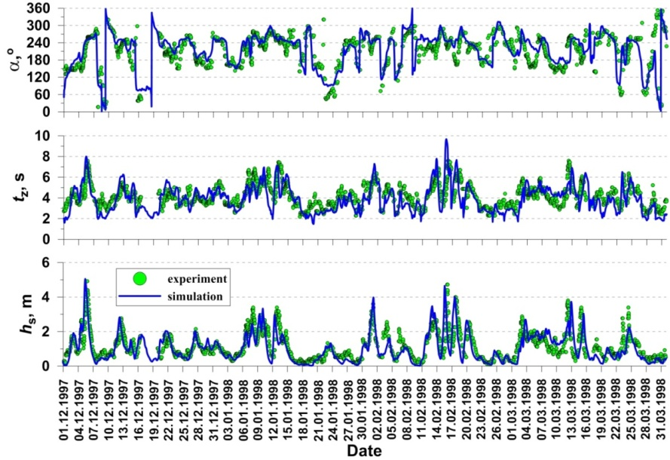

*Fig. 5. Comparison of the experimental data and results of modeling. The significant heights and average wave periods, as well as the directions of propagation. Station 1а (Datawell Waverider Gelendzhik) from Table 1*

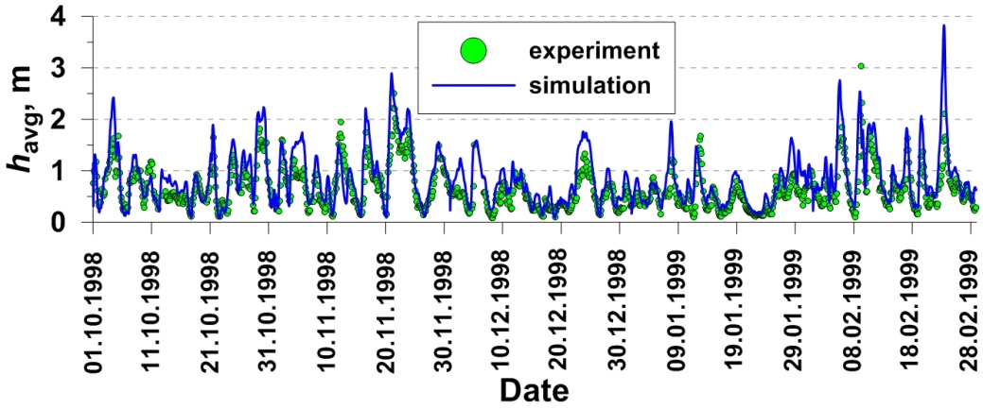

*Fig. 6. Comparison of the experimental data and results of modeling. Average wave heights.. Station 7 (Wave Stuff MHI) from Table 1*

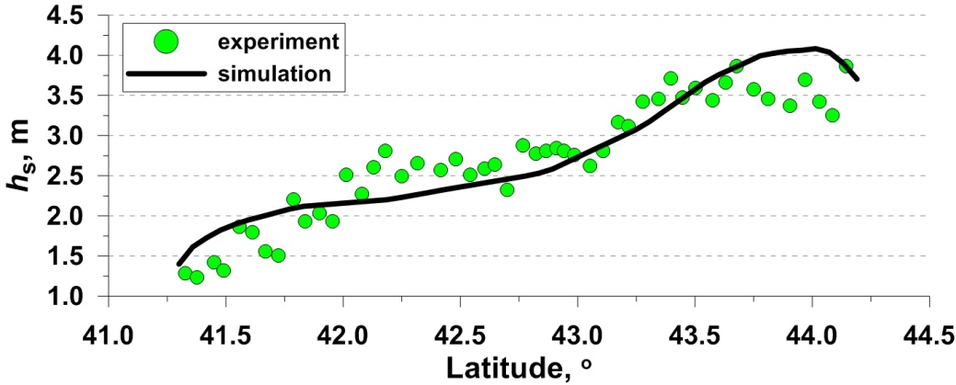

*Fig. 7. Comparison of the experimental data and results of modeling. Significant wave heights. Station 9 (Satellite ERS-2) from Table 1*

Analysis of the figures 5-7 gives reason to believe that the ERA-Interim fields of surface pressure as the wind forcing of the spectral model is perfectly acceptable.

For quantitative assessment of correspondence of calculated values to experimental data, the following parameters were calculated: standard error (Bias), standard deviation (RMS), scattering index (SI) and correlation coefficient (R). Statistical evaluations of these parameters are made by the relations:

, ,

, ,

where *S*i and *O*i - calculated and observed values, respectively, and - their average meanings. The calculated statistics for the series of significant wave heights are shown in Table. 2.

*Table 2. Average errors, standard deviations, scattering indices and the correlation coefficients for the calculated and experimental observation series of significant wave heights*

|  |  |  |  |  |  |
| --- | --- | --- | --- | --- | --- |
| **Station** | **Device** | **Bias, m** | **RMS, m** | **SI** | **R** |
| **1a** | Datawell Waverider | -0.07 | 0.36 | 0.32 | 0.71 |
| **1b** | -0.04 | 0.29 | 0.28 | 0.84 |
| **2** | -0.15 | 0.28 | 0.27 | 0.62 |
| **3a** | -0.15 | 0.22 | 0.34 | 0.67 |
| **3b** | -0.02 | 0.30 | 0.37 | 0.65 |
| **4** | Wave stuff ADCP Sattellite | 0.20 | 0.23 | 0.38 | 0.73 |
| **5** | 0.13 | 0.23 | 0.31 | 0.60 |
| **6** | 0.25 | 0.31 | 0.34 | 0.79 |
| **7** | 0.51 | 0.24 | 0.37 | 0.84 |
| **8a** | 0.39 | 0.35 | 0.39 | 0.80 |
| **8b** | 0.32 | 0.28 | 0.32 | 0.82 |
| **8c** | 0.21 | 0.23 | 0.28 | 0.79 |

Statistical analysis of the conformity of the model results with experimental data revealed two characteristic trends:

1. The model slightly **underestimate**s the importance of wave heights in comparison with experimental data. This applies to the data obtained using specialized marine devices, in our case - Datawell Waverider. The results of calculation, based on wave model, generally correspond to observational data perfectly, especially for station 1 Gelendzhik. Low correlation coefficients for stations 2 and 3 (Hopa and Sinop) are explained, in particular, by the presence of a significant number of gaps in the observations.

The model slightly **overestimates** the meanings of wave heights in comparison with experimental data. On average, the excess is 0.2-0.3 m, and refers to data of wave measuring rails, ADCP and satellites. At the same time, we note the high correlation coefficients, especially for satellite data.

A clear graphic illustration of the results of model verification can serve a Taylor diagram ([11]), shown in Fig. 8. The diagram reflects the quality of the spectral model in terms of the "correlation coefficient" - "standard deviation". Radial axis (correlation) is represented in a logarithmic scale. Station numbers correspond to Table. 1.

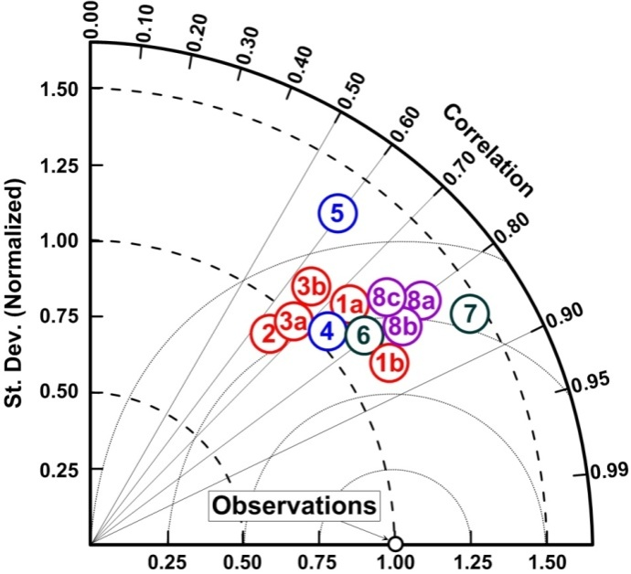

*Fig. 8. Taylor diagram for series of significant wave heights*

For ease of comparison, the normalized standard deviation is used, wherein the statistical characteristics of the series of experimental observations are located at one point. This allows to assess the quality of the model for all monitoring stations visually. As can be seen from Fig. 15, the worst performance is demonstrated by spectral model for the Sea of ​​Azov. In this regard, it has to be noted, that the Sea of Azov, due to geographical characteristics (small size), and shallow water, requires separate consideration. The best agreement between the calculated and experimental data was obtained for Gelendzhik station. This is due, primarily, to the best quality of the field data, which implies: the greatest total length of observation the Black Sea environment in this point, practically, continuous recording; correct configuration of mode of information collection from the device.

Thus, we can conclude the spectral wave model DHI MIKE 21 SW has been successfully verified for the Black Sea conditions and can be used as a tool for studies of its wave climate.

III. RESULTS AND DISCUSSION

As a result of this work, a vast dataset is produced, consisting of fields of calculated wind waves parameters for the Black and Azov seas with a time step of 1 hour and covering a period of 37 years (from 1979 to 2015). The array of calculated characteristics includes:

* spatial distribution of significant and maximum wave heights, average period, periods of peak of the spectrum, the waves directions;
* frequency and frequency-directional spectra of wind waves;
* power of wind waves.

In deep water, the irregular wind wave power is estimated by the expression (Boyle, 2004):

,

where *h*s – significant wave height, *t*e – energy wave period, ** – density of water, *g* – acceleration of gravity. If significant wave height is represented in meters, peroid – in seconds, then power of wind waves will be expressed in kilo watts per meter of wave front. Since the significant wave heights and periods are determined by points of the energy spectrum, the estimation of energy capacity of wind waves, of course, depends entirely on the correctness and adequacy of the spectral model while playing all the stages of development of waves. The greatest wave potential exists in a south-western part of the Black Sea. This is clearly seen on the averaged over 37 years fields of capacity of wind waves (Fig. 8).

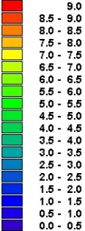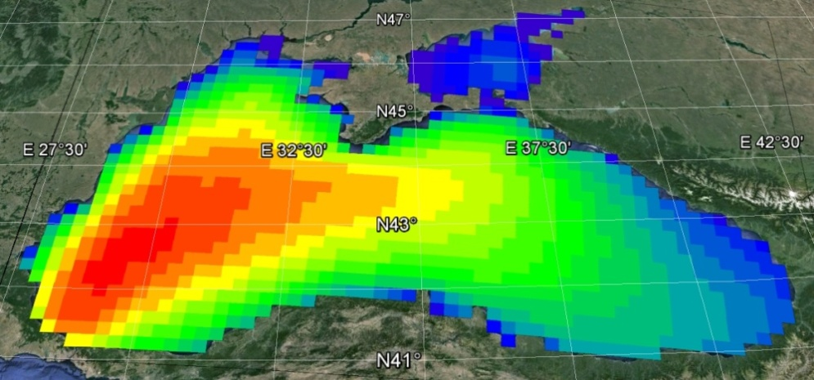

*Fig. 8. The average wind waves power (kW/m) in the Black and Azov seas for 1979-2015.*

In the area of Anapa bay bar, an average power of wind waves is 4-5 kW/m and subjected to a considerable interannual variability (Fig. 9). Most stormy were 1981, 1998, 1993, 2001, 2007 and 2015 years; least stormy – 1982, 1984, 1994, 1996 and 2009 years.

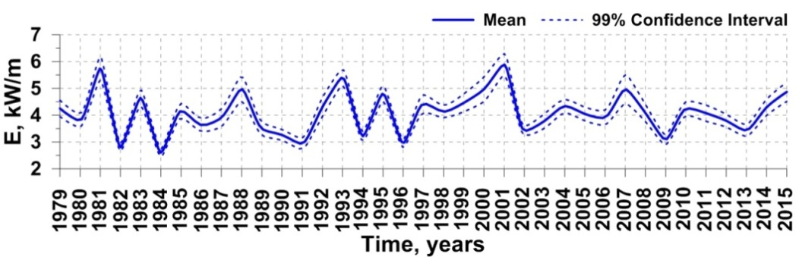

*Fig. 9. Average power of wind waves in Anapa bay bar area for the period 1990-2014.*

In the distribution of storm surge, two directions are clearly distinguished: south-west and north-east (Fig. 10). The rarest observed storms near Anapa bay bar are of south-eastern and north-western directions.

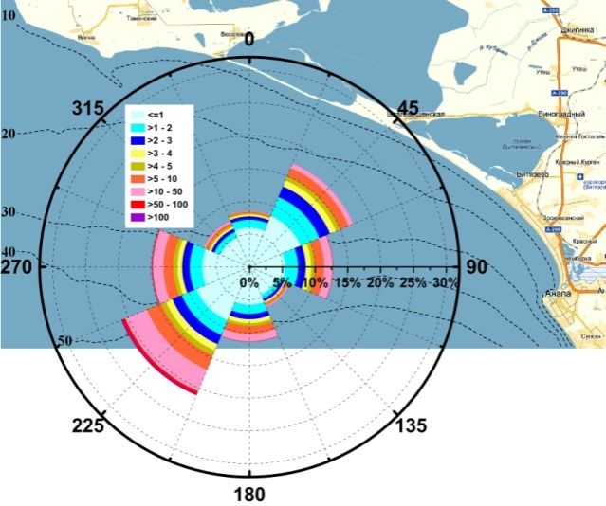

*Fig. 10. Rose of wind waves in the area of Anapa bay bar for the entire period of analysis (1979-2015). The scale is given in kW/m*

Occurence of wind waves in directions are subjected to interannual fluctuations, which are shown in Fig. 11.

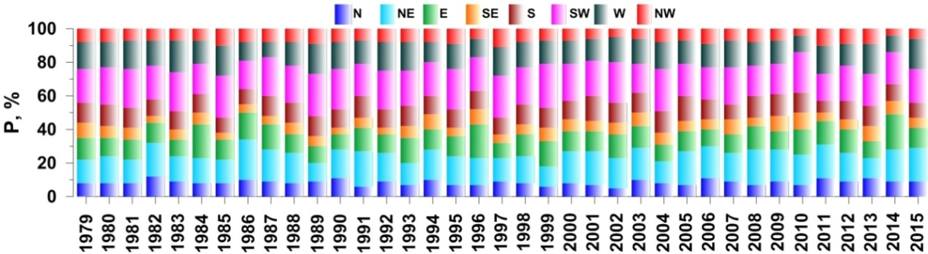

*Рис. 11. Occurrence of wind waves in directions for the period between 1979-2015.*

We pose the question: are there interannual sustainable trends in contribution to the overall waves repeatability of different directions? To answer this question, we use the procedure detailed in [2]. This procedure implements a non-parametric Mann-Kendall test. The method does not require knowledge of the law of distribution of initial values, and can also take into account the time scale unevenness and gaps in the data. The method considers three main statistical metrics:

* Mann-Kendall statistics (S), the sum of the differences between successive values;
* CF, Confidence Factor;
* COV, Coefficient of Variation.

The combination of these three metrics reveals the trend components in the raw data, as well as to evaluate the sign and the statistical significance of trends. The final result is presented in following terms:

* Increasing – S>0 and CF>95%;
* Probably Increasing – S>0 and 90%<CF<95%;
* No Trend – (S>0 and CF<90%) or (S≤0 and CF<90% and COV≥1);
* Stable – S≤0 and CF<90% and COV<1;
* Probably Decreasing – S<0 and 90%<CF<95%;
* Decreasing – S<0 and CF>95%.

The differences of the terms «No Trend» and «Stable» apply only to the degree of scatter in the absence of clear trends. Results of the study of possible trends in the frequency of occurrence of wind waves in different directions at the control points are presented in Table. 3. As can be seen from Table. 3, in the area of ​​Anapa bay bar there has been a redistribution of wave energy on the directions of propagation over the past 37 years. There is a steady increase in the share of the waves of northeastern direction along with a decrease in the contribution of the south-western waves.

*Table 3. Analysis of trends in the frequency of occurrence of wind waves by directions for the period 1979-2015*

|  |  |  |  |  |  |  |  |  |
| --- | --- | --- | --- | --- | --- | --- | --- | --- |
| **Direction** | **N** | **NE** | **E** | **SE** | **S** | **SW** | **W** | **NW** |
| COV | 0.19 | 0.17 | 0.22 | 0.25 | 0.14 | 0.12 | 0.17 | 0.20 |
| S | 22 | 128 | 25 | 113 | 10 | -111 | -78 | -71 |
| CF | 60.7 | 95.2 | 62.2 | 92.8 | 54.7 | 95.1 | 84.2 | 81.9 |
| **Test**  **Interpretation** | **No**  **Trend** | **Increasing** | **No**  **Trend** | **Probably Increasing** | **No**  **Trend** | **Decreasing** | **Stable** | **Stable** |

Let’s note an important detail. We consider the dynamics of the surface waves, regardless of the genesis, in other words, the final picture of waves. More complete statistical estimations can be obtained by dividing the surface waves on the pure wind and swell, which will be the subject of further research.

IV. CONCLUSIONS

The main objective of the present work is the analysis of the spatial-temporal variability of the wave climate in the Black Sea in the period from 1979 to 2015. The analysis is based on the results of mathematical modeling conducted with the help of modern spectral wave model DHI MIKE 21 SW. Verification of wave model is made with the involvement of numerous instrumental observations of parameters of wind waves in the Black and Azov Seas.

Main results:

1. A vast dataset has been obtained, consisting of fields of calculated parameters of wind waves of the Black and Azov seas with a time step of 1 hour and covering a period of 37 years (from 1979 to 2015).
2. The greatest wave potential has been noted in a south-western part of the Black Sea. The average power for the south-western part reaches 8-10 kW per meter of wave front and drops to 2-3 kW/m, in the eastern part of the sea.
3. In the area of ​​Anapa bay bar, average power of wind waves is 4-5 kW/m, undergoing a considerable interannual variability. In the rose of wind waves, there are two prevailing directions: north-east and south-west. In the inter-annual terms there is a steady increase in the share of the waves of northeastern direction with a decrease in the contribution of the south-western waves.

The results will be used later in the modeling of the dynamics of the underwater part of Anapa bay bar and evolution of the coastline.

V. ACKNOWLEDGMENTS

This work was initializated by the Russian Foundation for Basic Research (Project 14-05-00040). The processing of experimental data was supported by the Russian Science Foundation, project no. 14-17-00547. The calculations and analysis of the results were supported by the Russian Science Foundation, project no.14-50-00095.

VI. REFERENCES

1. Arkhipkin V.S., Gippius F.N., Koltermann K.P., Surkova G.V. 2014. Wind waves in the Black Sea: results of a hindcast study. Nat. Hazards Earth Syst. Sci., 14, 2883–2897, doi: 10.5194/nhess-14-2883-2014.
2. Aziz J.J., Ling M., Rifai H.S., Newell C.J., Gonzales J.R. 2003. MAROS: A Decision Support System for Optimizing Monitoring Plans. Ground Water, 41(3): 355-367.
3. DHI Water & Environment. 2007. MIKE 21, Spectral Wave Module.
4. Dimitrova M., Kortcheva A., Galabov V. 2013. Validation of the operational wave model WAVEWATCH III against altimetry data from JASON-2 satellite. Bul. J. Meteo & Hydro 18/1-2, 4-17.
5. Kos'yan R.D., Divinsky B.V., Pushkarev O.V. 1998. Measurements of parameters of wave processes in the open sea near Gelendzhik. The Eight Workshop of NATO TU-WAVES/Black Sea, METU, Ankara, Turkey, p. 5-6.
6. Özhan E., Abdalla S. 1997. Wind Wave Climate of the Black Sea: Progress of the NATO-TU WAVES Project. Ocean Wave Measurement and Analysis, p. 962-974.
7. Polonsky A.B., Fomin V.V., Garmashov A.V. 2011. Characteristics of wind waves of the Black Sea. Reports of the National Academy of Sciences of Ukraine, 8, p. 108-112. ISSN 1025-6415.
8. Wave Climatology of the Turkish Coast: NATO TU-WAVES Project. http://www.medcoast.org.tr/tu-waves/introduction.htm.
9. Reference data of the wind and wave conditions for Baltic, North, Black, Azov and Mediterranean Seas. 2006. Russian Maritime Register of Shipping., St. Petersburg. ISBN 5-89331-071-3.
10. Rusu L., Bernardino M. & Guedes Soares C. 2014. Wind and wave modelling in the Black Sea. Journal of Operational Oceanography, 7:1, 5-20, DOI: 10.1080/1755876X.2014.11020149.
11. Taylor K. 2001. Summarizing multiple aspects of model performance. J. Geophys. Res., 106, p. 7183–92.
12. Trusca C.V. 2005. Reliability of SWAN model simulations for the Black Sea Romanian coast // Maritime transportation and exploitation of ocean and coastal resources – Guedes Soares, Garbatov & Fonseca (Eds). Taylor & Francis Group, London, ISBN 0 415 39036 2.
13. Zatsepin A.G., Piotouh V.B., Korzh A.O., Kukleva O.N., Soloviev D.M. 2012. Variability of currents in the coastal zone of the Black Sea from long-term measurements with a bottom mounted ADCP. Oceanology. V. 52. N 5. P. 579-592.